Students in a college statistics class wanted to find out how common it is for young adults to have their ears pierced. They recorded data on two variables—gender and whether or not the student had a pierced ear—for all 178 people in the class. The two-way table summarizes the data.

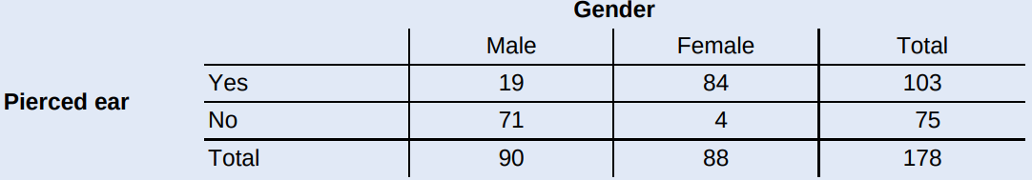

Suppose we choose a student from the class at random. Define event A as getting a male student and event B as getting a student with a pierced ear.

1. Find P(B).
2. Find P(A and B). Interpret this value in context.
3. Find P(A or B).

Draw a Venn Diagram!

If we know that a randomly selected student has a pierced ear, what is the probability that the student is male?

If we know that a randomly selected student is male, what is the probability that the student has a pierced ear?

* **Conditional Probability**
* Definition: The probability that one event happens _______________________________________________ is called a conditional probability. The conditional probability that event A happens given that event B has happened is denoted by ______________.
* Formula:
* **General multiplication rule for two events**

For any two events E and F,

**Practice:** The following table gives information on DVD players sold by a certain electronics store:

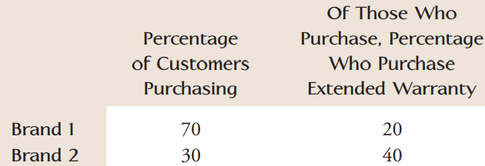A purchaser is randomly selected from among all those who bought a DVD player from the store. What is the probability that the selected customer purchased a Brand 1 model and an extended warranty?

* **Tree Diagram:**

P(getting higher than average GPA)=0.65. If you have a higher-than-average GPA, you have a 0.83 chance of being admitted. If you have a below or equal average GPA, you have a 0.39 chance of being admitted. **Q:** What is the probability of being admitted given that you have a higher GPA ?

Define: H = Event of getting higher than average GPA

A = Event of being admitted to your dream school

* **The law of total probability**
* If B1 and B2 are ____________ events with ______________________ , then for any event E

P(E) =

* Generally, if B1, B2, … , Bk are ____________ events with ___________________________ , then for any event E:

P(E) =

Homework:

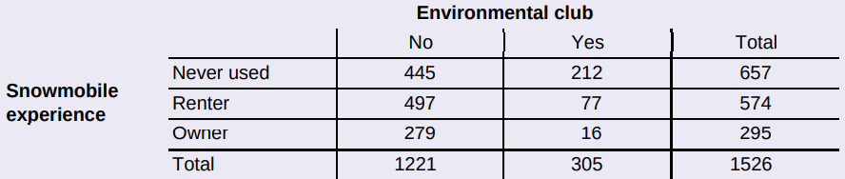Yellowstone National Park surveyed a random sample of 1526 winter visitors to the park. They asked each person whether he or she owned, rented, or had never used a snowmobile. Respondents were also asked whether they belonged to an environmental organization (like the Sierra Club). The two-way table summarizes the survey responses.

Suppose we randomly select one of the survey respondents. Define events E: environmental club member, S: snowmobile owner, and N: never used.

1. Find P(N | E). Interpret this value in context.
2. Given that the chosen person is not a snowmobile owner, what’s the probability that she or he is an environmental club member? Write your answer as a probability statement using correct symbols for the events.
3. Is the chosen person more likely to not be an environmental club member if he or she has never used a snowmobile, is a snowmobile owner, or a snowmobile renter? Justify your answer.